Experiment Number: 05

Name of the Experiment:
Verification of Superposition Theorem in DC circuit

Objective:
To Verify principle of Superposition theoretically and practically.

Theory:
In a linear, bilateral network, the response in any element is equal to sum of individual responses while all other sources are non-operative/ turned off.
Steps for solving network by Superposition Theorem:
Considering the circuit diagram A, let us see the various steps to solve the superposition theorem:

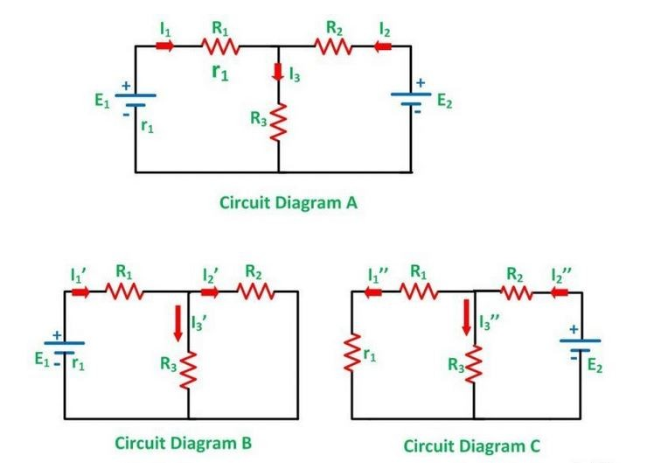

– Take only one independent source of voltage or current and deactivate the other sources.
– In the circuit diagram B shown above, consider the source E1 and replace the other source E2 by its internal resistance. If its internal resistance is not given, then it is taken as zero and the source is short-circuited.
– If there is a voltage source than short circuit it and if there is a current source then just open circuit it.
– Thus, by activating one source and deactivating the other source find the current in each branch of the network. Taking the above example find the current I₁’, I₂’and I₃’.
– Now consider the other source E2 and replace the source E1 by its internal resistance r1 as shown in the circuit diagram C.
– Determine the current in various sections, I₁’’, I₂’’ and I₃’’.
– Now to determine the net branch current utilizing the superposition theorem, add the currents obtained from each individual source for each branch.
– If the current obtained by each branch is in the same direction then add them and if it is in the opposite direction, subtract them to obtain the net current in each branch.

Circuit Diagrams:
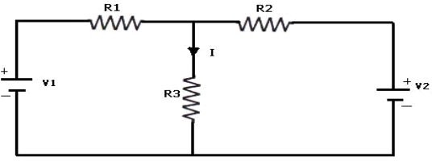
Fig. 5.1: Both Voltage Sources are acting (V1 &V2)
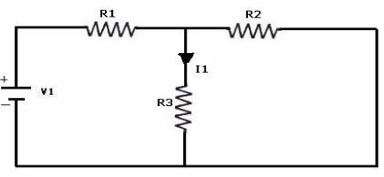
Fig. 5.2: Voltage Source V₁ is acting alone

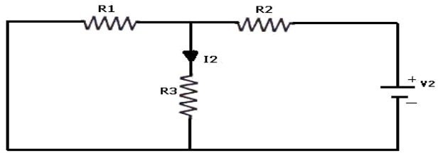
Fig. 5.3: Voltage Source V₂ is acting alone

Required Equipments:
  - Multimeter
  - Resistors
  - Bread Board
  - Connecting Wires
  - Power Supply

Procedures:
- Connect the circuit as shown in figure (5.1) and note down the current flowing through R3 and let it be I.
- Connect the circuit as shown in figure (5.2) and note down the ammeter Reading, and let it be I1.
- Connect the circuit as shown in figure (5.3) and note down the ammeter reading, and let it be I2.
- Verify for I= I1+I2.

Precautions:
- Check for proper connections before switching ON the supply
- The terminal of the resistance should be properly connected
- Follow the lab manual and circuit diagram for using the equipment. Directions in the user manual provide recommended operating procedures and safety precautions.
- Never hurry. Haste causes many accidents.
- Connect the power source last. Disconnect the power source first.
- Use safety googles if necessary.
- Notify lab assistant immediately if any injuries or hazard is happened
- Before connecting the power, check your wiring carefully for agreement with the wiring diagram for an accidental short-circuit and for loose connections.

Data Table:

Parameters | When both  V₁ & V₂  (I) | When  V₁≠0 & V₂=0 (I₁) | When  V₁=0 & V₂≠0  (I₂) | Sum of  I₁ and I₂
Current through R3 (Theoretical Values)
Current through R3 (Practical Values)

Data analysis:
- Analyze the obtained data and plot the figures if needed.
- Compare the simulation results with your experimental data /wave shapes and comment on the difference (If any).

Results and Discussion:
- Interpret the data /findings and determine the extent to which the experiment was successful in complying with the goal that was initially set.
- Detect the variation between theory and experimental result if any and propose the ways/procedures to overcome the variations.
- State the particular steps adopted to overcome the deviations between theory and experiment.
Conclusion:
Summarize the experiment and discuss whether the objectives were fulfilled or not within a short paragraph.

Reference:
- Robert L. Boylestad , “Introductory circuit analysis’’, prentice Hall , 12th Edition , Newyork, 2010, ISBN 9780137146666.
- Charles Alexander and Matthew Sadiku , “Fundamentals of Electric Circuits’’ 6th Edition ISBN 9780078028229 .

Pre-Lab Viva Questions:
- State Superposition theorem.
- How to find power using Superposition theorem?
- Write applications of super position theorem.

Post Lab Viva Questions:
- Is it possible to apply Superposition theorem to nonlinear circuit?
- Is it possible to apply Superposition theorem to ac as well as dc circuit?

